Self-description
Name:
Chinese name: Yuheng Hou
English name: Janet
Background: I am currently studying accounting at the Asia-Australia Business Collage
Liaoning University.
Future vocation aspirations: I plan to complete a 1-year internship at KPMG or PwC and obtain the CPA qualification. After graduation, I will join the finance team of a state-owned enterprise or multinational corporation, serving as a finance manager or accounting specialist.

Explain the SDG’s Purpose
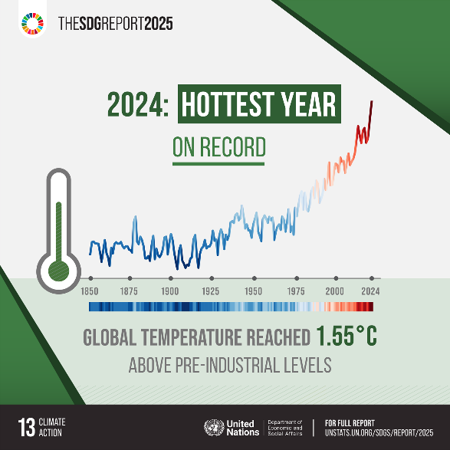
Source: Goal 13 | Department of Economic and Social Affairs
State the official title of the SDG (from the UN): Climate Action
Summarize what the goal aims to achieve by 2030: This goal aims to take urgent action to combat climate change and its impacts (United Nation, 2015).
This goal aims to urge all countries worldwide to proactively respond to the increasingly severe climate crisis. By 2030, all countries are required to comprehensively improve their capacity to resist and adapt to extreme climate disasters. Meanwhile, climate governance shall be integrated into national development planning, with corresponding capital and technological investment. So as to jointly mitigate various risks and hazards arising from global warming.
Mention 1-2 key targets or indicators under that goal:
Target 1: Strengthen resilience and adaptive capacity to climate-related hazards and natural disasters in all countries
Target 2: Integrate climate change measures into national policies, strategies and planning

Adverse Impact

Adverse impacts that China is currently dealing with
①China’s coal dependence in its energy structure
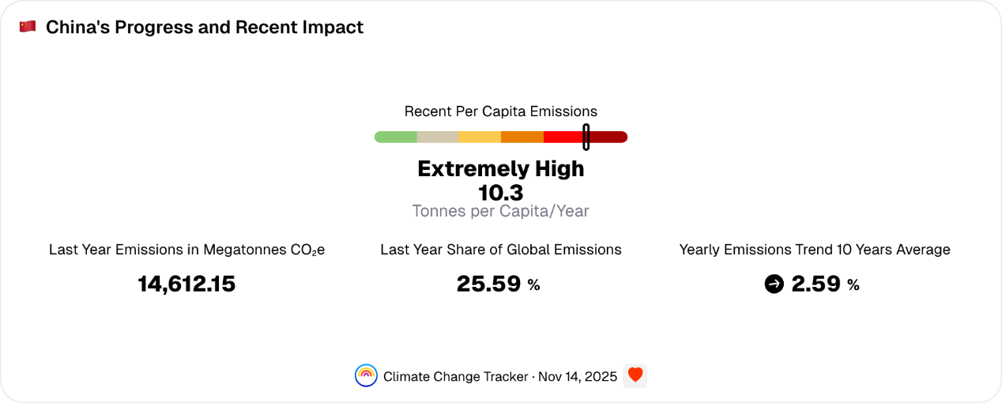
Source: China's Progress and Recent Impact | Climate Change Tracker
One of the core causes of China’s climate challenge is the sustained high emissions resulting from the long-standing coal-dominated energy structure. China possesses abundant coal reserves with low extraction costs, reaching 173,107.86 million short tons in 2023 (TheGlobalEconomy, 2023). At the same time, coal plays a critical role in ensuring stable energy supply in China. In 2024, China’s total carbon emissions accounted for approximately 25.6% (Climate Change Tracker, 2024) of the global total, with coal contributing the majority of this volume. Although decades of investment in renewable energy technology and manufacturing in China have yield remarkable outcomes, this success has not been effectively translated into substantial reductions in greenhouse gas emissions due to the sustained dependence on coal (Hilton, 2026).
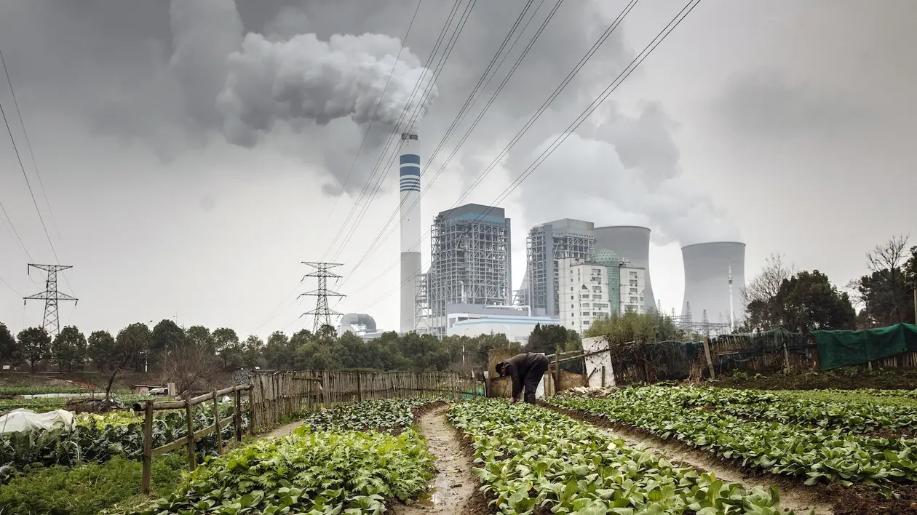
Source: As It Boosts Renewables, China Still Can't Break Its Coal Addiction - Yale E360
②Industrialization and Urbanization

Source: China's Urbanization 2021 - CGTN
The combined effects of industrialization and urbanization have further intensified climate issues. In the industrial sector, fundamental industries such as steel and cement serve as pillars of the economy. These industries not only rely on coal for heat supply, but coal also remains irreplaceable in certain production processes. Accelerated urbanization alters land surface characteristics, thereby affecting regional climates. The increasing proportion of impervious surfaces in cities has led to higher temperatures in urban centers compared to suburbs, making the urban heat island effects increasingly prominent. Meanwhile, expanding cities continue to encroach upon ecological spaces such as forests and wetlands, resulting in a continuous decline in carbon sequestration capacity.
③Agricultural activities
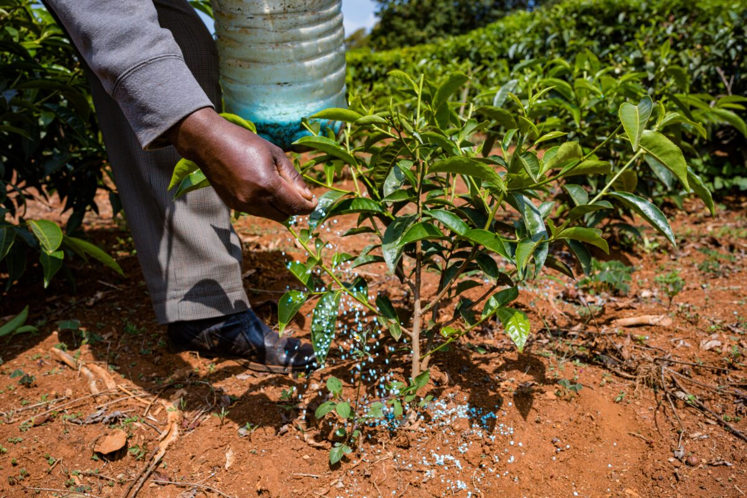
Source: Get to know the practical methods of fertilizer application – Agriculture Monthly
Agricultural production also affects the climate. Livestock farming, rice cultivation, and fertilizer application release greenhouse gases including methane and nitrous oxide. The warming effect of these two gases is far greater than that of carbon dioxide. Fertilizers are the primary source of nitrous oxide emissions and have become a major cause of water pollution. The continuous accumulation of large volume of potent greenhouse gases intensifies the greenhouse effect and exacerbates climate anomalies (Jinxia Wang & Jikun Huang & Scott Rozelle, 2010).
④Natural variability
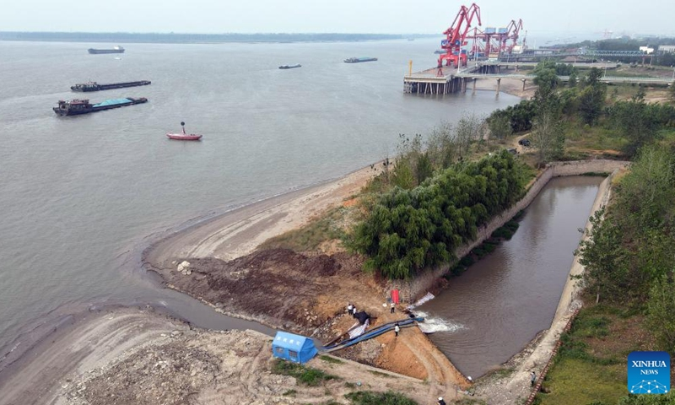
Source: El Niño will lead to more extreme weather for China: meteorologist - Global Times
Although natural variability is not the primary cause, it has exacerbated the impacts of human-induced emissions. The EI Nino event led to a 1.2-degree Celsius increase in sea surface temperatures in the central and eastern equatorial Pacific. This directly triggered summer heatwaves and droughts in northern China, while southern regions experienced extreme rainfall and flooding, affecting drinking water supplies, agricultural irrigation, industrial production, and urban water systems.

Who causes or is affected by the problem
Who causes
① Industries dependent on coal resources
② Agricultural production entities
③ Coal-fueled vehicle users
④ Government inter-regional governance department
Who is affected
① Resident
② Ecologically protected areas

What is the carbon footprint
Carbon footprint refers to a comprehensive quantitative indicator that aggregates the direct and indirect greenhouse gas emissions (including carbon dioxide, methane, nitrous oxide, etc.) generated by an individual, enterprise, organization, or specific activity throughout its entire life cycle. These emission sources are diverse, including energy consumption, transportation, waste generation and manufacturing processes (Green.Earth, n.d.). It is typically expressed in terms of “carbon dioxide equivalents (CO₂e)” as a standardized unit of measurement. In essence, this concept is a core indicator for measuring the contribution degree of various entities or activities to global greenhouse effect.

Explaining the Purpose of Your Action
Action: Walk, bike, or take public transport
The world’s roadways are clogged with vehicles, most of them burning diesel or gasoline. Walking or riding a bike instead of driving will reduce greenhouse gas emissions -- and help your health and fitness. For longer distances, consider taking a train or bus. And carpool whenever possible. Living car-free can reduce your carbon footprint by up to 2 tons of CO2e per year compared to a lifestyle using a car (Nations, n.d.).

Source: Environmental Benefits Of Public Transportation | ECO Reside
The core mechanism by which adopting walking, biking or taking public transport reduces emissions is that these low-carbon or zero-carbon travel modes replace individual travel powered by fossil fuels, primarily gasoline or diesel vehicles. Walking and biking produce no direct emissions at all, while public transport can significantly cut per capita carbon emissions due to its higher passenger capacity per unit of energy consumed. The carbon footprint of bikes mainly comes from manufacturing and maintenance, averaging about 5 grams of carbon dioxide per kilometer. In contrast, a diesel bus emits around 101 grams of carbon dioxide per passenger per kilometer (FasterCapital, 2025). Additionally, these choices reduce the overall demand for private vehicles, thereby decreasing indirect emissions associated with car manufacturing and maintenance. These changes collectively reduce the total emissions of carbon dioxide and air pollutants into the atmosphere through both direct and indirect pathways.
Example: For daily commutes to work or school, prioritize public transport options such as subway and bus instead of by private car. For short-distance trips, such as grocery shipping at the supermarket near your residence, attending a gathering with friends in the neighborhood, or studying at a nearby library, choose walking or biking directly. This approach not only allows you to flexibly avoid congested road sections, but also reduces carbon emissions.
Co-benefits:
- Ease traffic congestion: Reducing the use of private vehicles can lower vehicle density on urban roads, effectively alleviate commuting congestion during peak hours and improve the operational efficiency of transportation systems.
- Improve physical and psychological health: Regularly walking or biking for a certain distance every day can effectively enhance cardiovascular function and reduce the risk of diseases such as obesity and hypertension. Moreover, increasing the duration of outdoor activities can alleviate daily stress and improve mental health.
- Reduce economic expenditure: Opting for public transport, walking or biking can eliminate multiple expenditures associated with private car use, including fuel costs, parking fees and insurance, thereby reducing living burdens.
- Optimize the ecological environment: Mitigation of traffic congestion and reduction of private vehicle usage can further lower urban noise pollution and exhaust emission pollution (Hodges, 2025), thereby improving both residents’ living quality and urban air quality.
- Ensure national energy security: As private car usage decreases, fuel consumption also declines accordingly. This can reduce the country’ dependence on petroleum imports, mitigate the geopolitical risks associated with energy supply, while creating greater space for energy structure transition.

Carbon footprint calculator
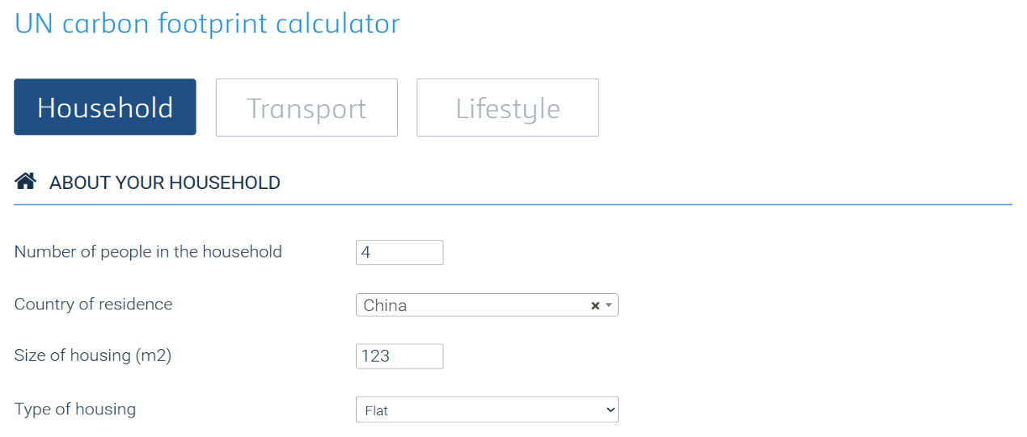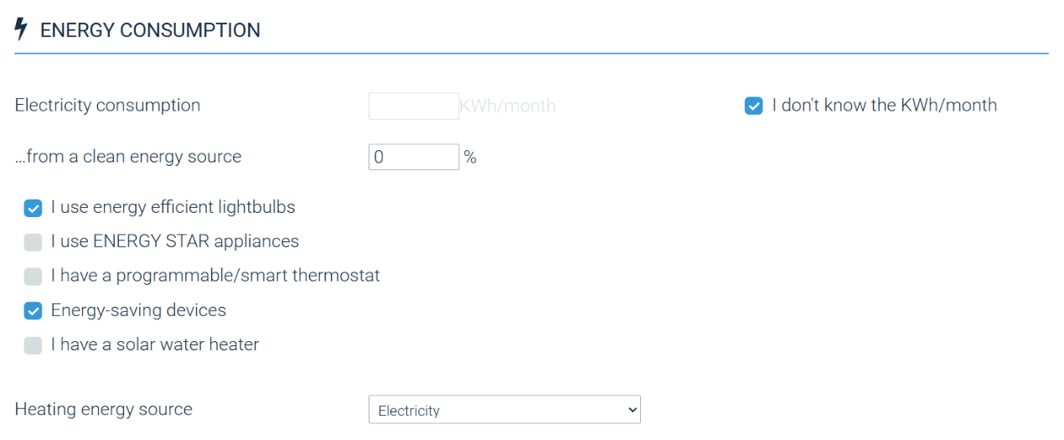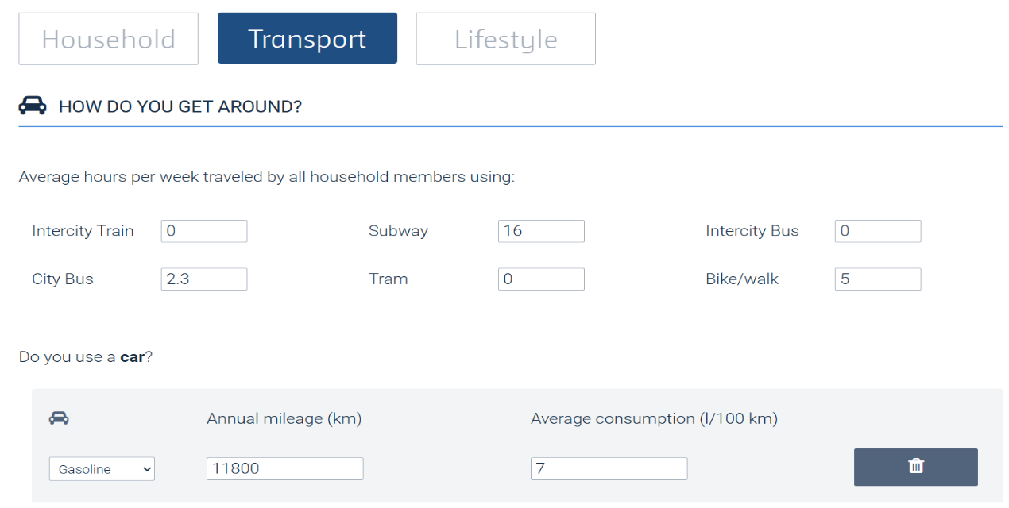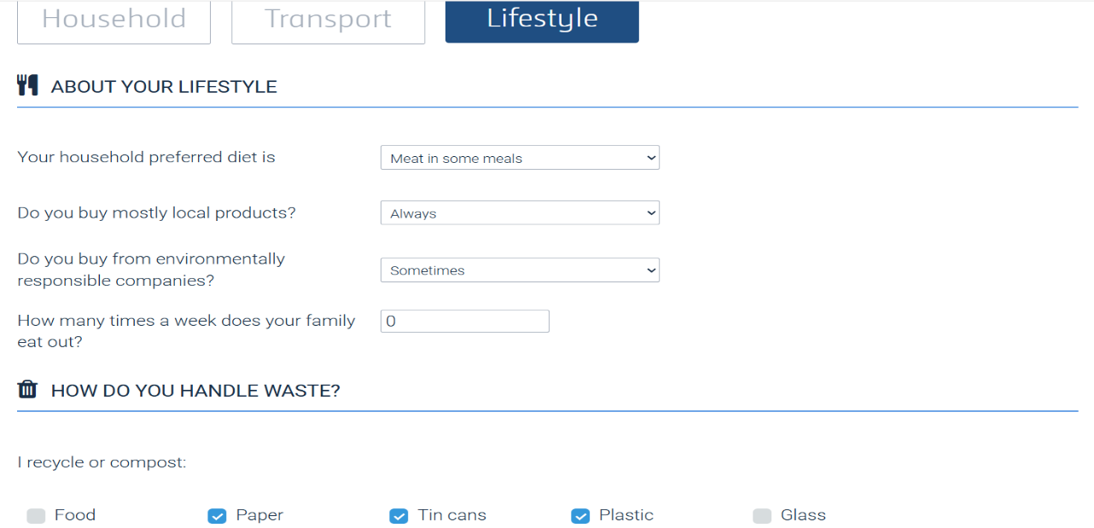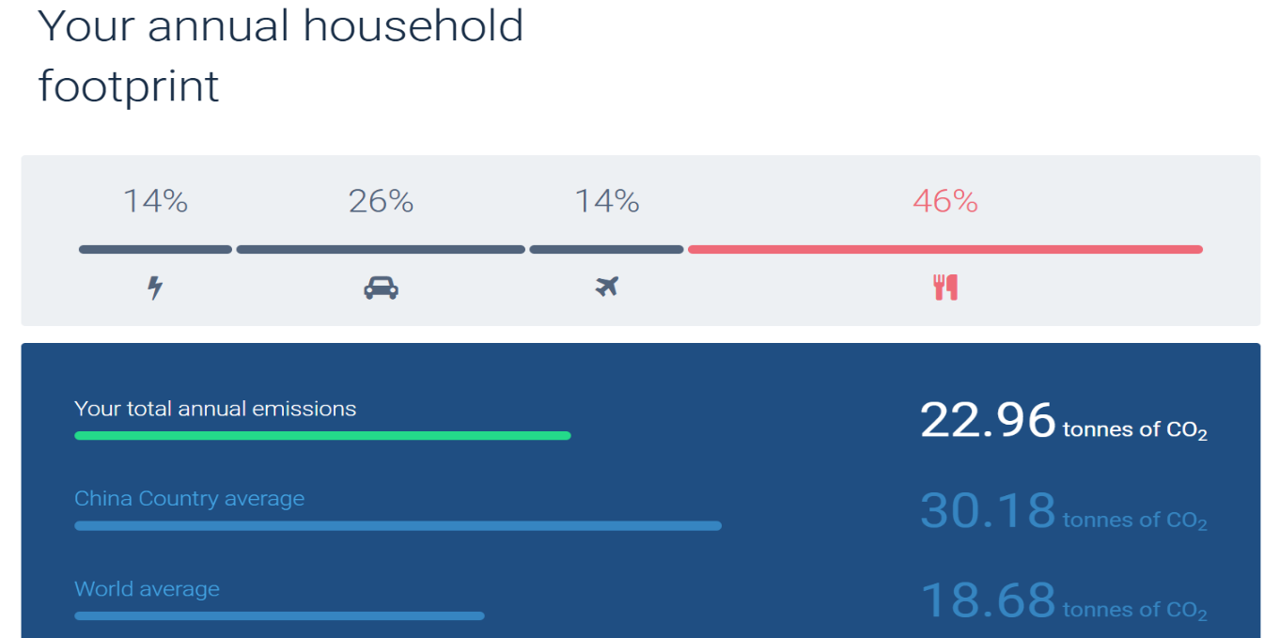
Source: United Nations online platform for voluntary cancellation of certified emission reductions (CERs)
The annual carbon emission of my household is 22.96 tons of carbon dioxide equivalent. Based on a four-member household, the per capita annual carbon emission is approximately 5.74 tons of carbon dioxide equivalent. Although this figure is lower than the average level of Chinese households, it is still far higher than the per capita target of 2 tons of carbon dioxide equivalent by 2030 proposed by the United Nations, reaching nearly three times the target value. From the perspective of emission structure, food consumption accounts for the largest proportion, while transportation accounts for 26%, which mainly comes from the use of private cars. Therefore, emission reduction targets are mainly concentrated in two areas: dietary optimization and green travel. Carbon emissions can be reduced by means of cutting meat consumption, increasing the use of public transport, as well as walking and biking, so as to gradually approach the set target.
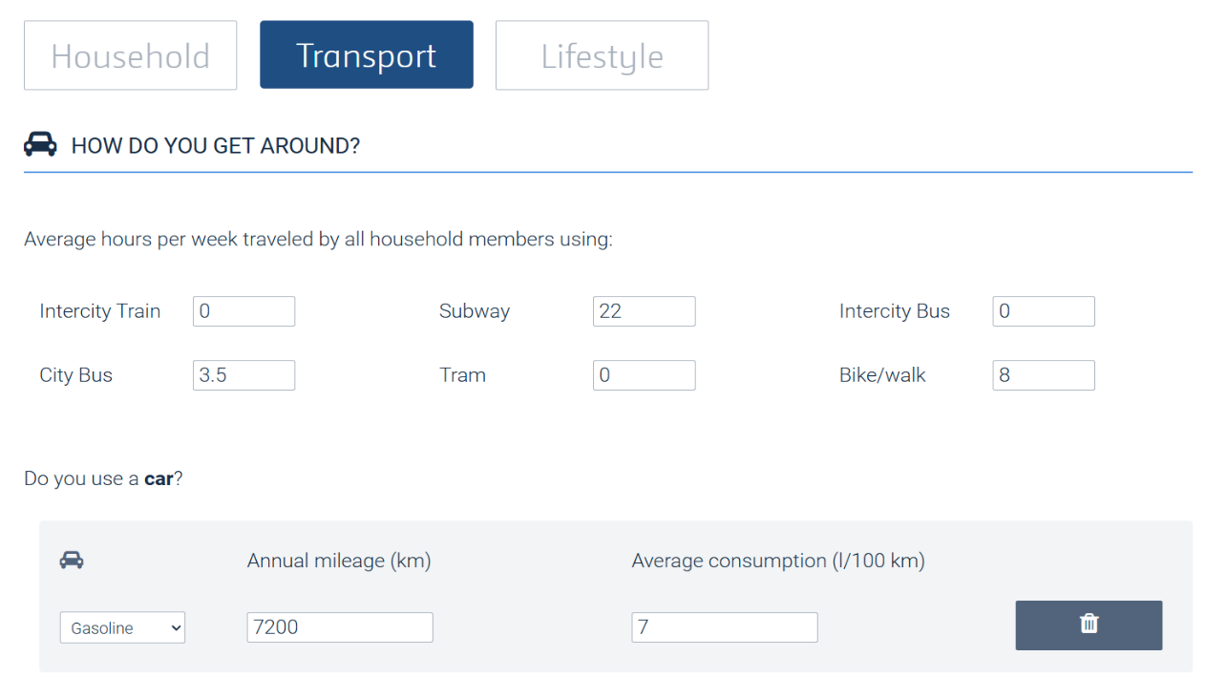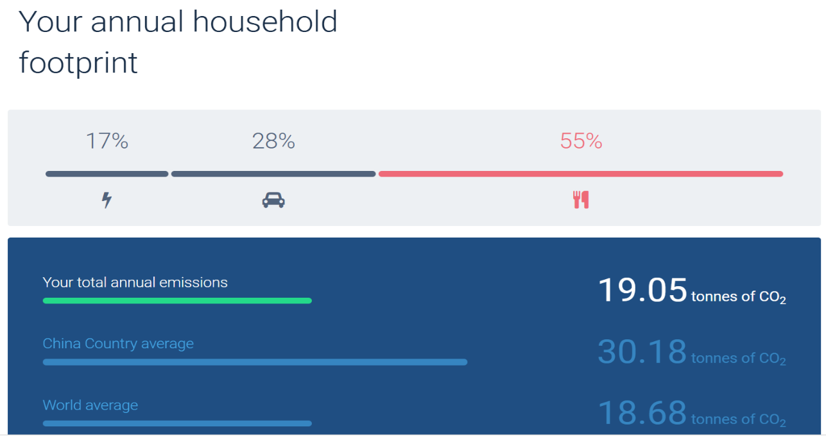
Arguing Credibility: After the implementation of the initiative, the household annual carbon emission reaches 19.05 tons of carbon dioxide equivalent, with a per capita emission of 4.76 tons- a reduction of approximately one ton compared to before, demonstrating significant results. This transportation emission reduction measure proves to be an effective solution: on the one hand, it directly reduces fossil fuel consumption by lowering private car usage; on the other hand, it aligns well with the family structure consisting of two working adults, one student, and one elderly member. Public transport, biking or walking fully met our daily short-distance travel needs.

Reference
Climate Change Tracker. (2024). China's Progress and Recent Impact. https://climatechangetracker.org/nations/greenhouse-gas-emissions/china/progress-and-recent-impact
FasterCapital. (2025, April 9). Bike Environmental Impact: Biking vs: Public Transportation: Which Is Better for the Planet. https://fastercapital.com/content/Bike-Environmental-Impact--Biking-vs--Public-Transportation--Which-Is-Better-for-the-Planet.html
Green.Earth. (n.d.). Understanding carbon footprints: impact, benefits, and reporting. https://www.green.earth/carbonfootprints
Hilton, I. (2026, March 26). As It Boosts Renewables, China Still Can’t Break Its Coal Addiction. Yale School of the Environment: https://e360.yale.edu/features/china-coal-five-year-plan#:~:text=China%20is%20the%20biggest%20installer%20of%20renewable%20energy%2C,the%20way%20to%20becoming%20carbon%20neutral%20by%202060.
Hodges, M. (2025, October 13). Eco-Friendly Commutes: Walking And Biking's Impact On Our Planet. SHUN WASTE: https://shunwaste.com/article/how-does-walking-or-riding-a-bike-affect-the-environment
Wang, J., Huang, J., Rozelle, S. (2010, May 1). Climate Change and China's Agricultural Sector: Impacts, Adaptation, and Mitigation. Stanford University: https://aparc.fsi.stanford.edu/publications/climate_change_and_chinas_agricultural_sector_impacts_adaptation_and_mitigation
NationsUnited. (n.d.). Actions for a healthy planet. United Nations: https://www.un.org/en/actnow/ten-actions
TheGlobalEconomy. (2023). China: Coal Reserves. https://www.theglobaleconomy.com/China/coal_reserves/
United Nation. (2015, September 25). Department of Economic and Social Affairs. Sustainable Development: https://sdgs.un.org/goals/goal13#targets_and_indicators

